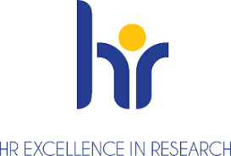
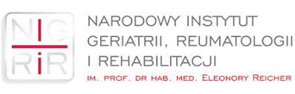
SCIENCE MEETING
Speeches will be held:
Marzena Ciechomska - Pathophysiology and Immunology Department
subject: „The application of high-pass tests in the pathogenesis of systemic scleroderma"

Jakub Owoc - Gerontology, Public Health and Education Department
Subject: Burnout syndrom among doctors - personal or systemic problem? Research results".

On 11 March, at 11.00 a.m., auditorium NIGRiR

